**How to install node js?**

**STEP 1)**

Install Node.js app**.**

**STEP 2)**

Create a folder on desktop with name ReactJS or any name of folder you want**.**

**STEP 3)**

Open such folder with text editor VS Code.

**STEP 4)**

Create an APP using Vite:

Write command npm create vite@latest on terminal.

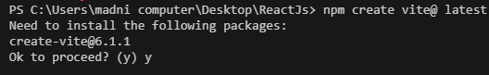

Click **Y:**

Select **Framework**:React

Select **Variant**:Javascript

**STEP 5)**

Run **cd my-app.**

And **npm install.**

And **npm run dev.**

**STEP 6)**

Following links will show as below.

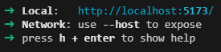

Click on local link by pressing control,then you will see your app running in chrome as below.

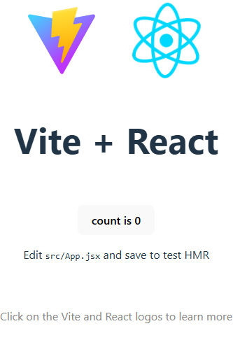

**STEP 7)**

Run **npm run build.**

Due to this command built files will be in dist folder.

These files optimize project like reduce installation time etc.

**Last STEP)**

Open your project and start code.

**\*\*\*\*\*\*\*\*\*\*\*\***